Year 10
Pathway 2

Term 4 Test

2018


Name: ______________________ Class: ______ Time: 55 minutes Total Mark:____/48

Show working and answers on this sheet. Show working in sufficient detail to support your answers. Incorrect answers without supporting reasoning will be allocated zero marks.

Resources: 1 A4 page of notes (2 sided), Calculator allowed.

Section 1: Multiple Choice (choose just one answer) 10 Marks
- Which of the following equations is a parabola?
  - y = 2x + 4
  - y = 2x³ + 4
  - y = 2x² + 4
  - y = 2^{x}

- Which is the most basic equation of a parabola?
  - y = x²
  - y = 2x² + 3
  - y = -x² -4
  - y = -x²

- What happens to the parabola when you multiply its equation by a number bigger than 1?
  - Graph moves UP
  - Graph gets WIDER
  - Graph moves DOWN
  - Graph gets NARROWER

- When you add a number to y=x² what happens to the graph?
  - Graph moves UP
  - Graph moves to the RIGHT
  - Graph moves DOWN
  - Graph moves to the LEFT

- Which way does the graph move if the equation looks like y = (x - k)² ?
  - Graph moves UP
  - Graph moves to the RIGHT
  - Graph moves DOWN
  - Graph moves to the LEFT

Question 6-10 refer to the graph on the right
- What is the turning point of this graph?
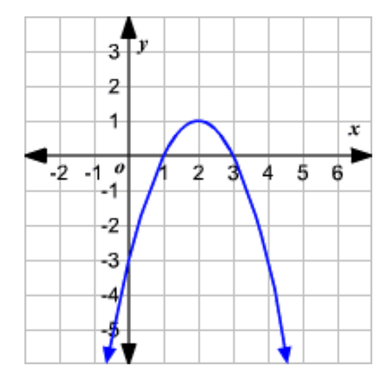
  - x=2
  - y=-3
  - (2, 1)
  - y=1

- What are the coordinates of the y-intercept?
  - (-3, 0)
  - (0, -3)
  - (2, 1)
  - y=-3

- What are the x-intercepts for this graph?
  - 1 and 3
  - 1 and -3
  - 0 and -3
  - 0 and 3

- Does this graph show a maximum or a minimum?
  - Maximum
  - Minimum

- What is the axis of symmetry for this graph?
  - y=2
  - x=2
  - x=0
  - y=0

Section 2: Short Answer

Question 11 2 marks

Colin invests $5000 for 5 years at 5.25% p.a. How much more will he have in his account at the end of the 5-year period than if the money had been invested at 5.25% simple interest?

Question 12 6 marks
Calculate the total amount owing, correct to the nearest cent, after 5 years on a loan of
$25 000 if the 7.2% p.a. interest is compounded:
(a) annually (b) half-yearly (c) quarterly

Question 13 6 marks
Factorise each expression.
(a) 15a² − 3a (b) 2x(a − 4) − 3(a − 4)

- (c) 5x2 – 3x + 2x2 + 10x

Question 14 6 marks
Use factorisation to determine the value of the x-intercepts of these quadratic equations
- y = x2 + 7x + 12 b) y = x2 - 5x - 14

- y = x ² – 9x + 8

Question 15 6 marks
State the following features of the quadratic graph shown.
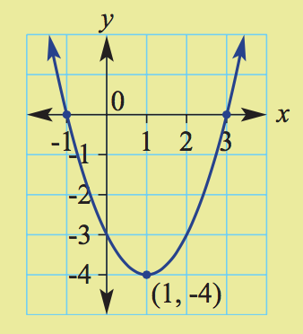
A Turning point and whether it is a maximum or a minimum (2)
_______________________
B Axis of symmetry (1)
_______________________
C x-intercepts (2)
_______________________
D y-intercept (1)
_______________________

Question 16 2 marks
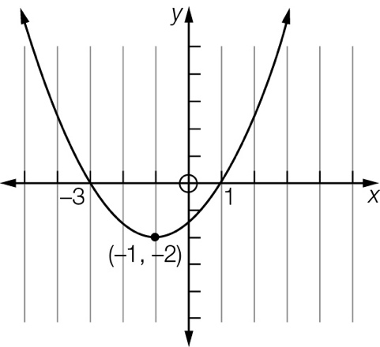
Find the equation for each of the following graphs.

Question 17 10 marks
Consider the equation y = 2x2 - 8.
- Set up a table of values with x-values from -3 to 3. (3)
- Plot the points on a coordinate plane and label the graph. (3)
- Find the turning point of the graph and label them. (1)
- Determine the x- and y-intercepts for the graph and label them. (3)

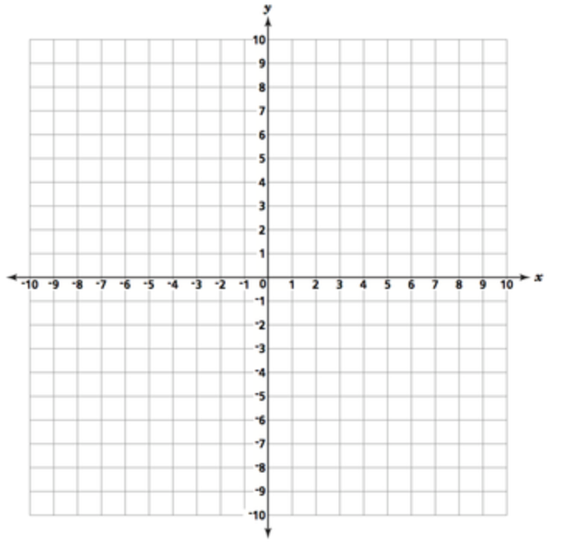

End of Test

